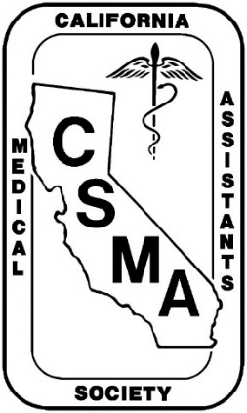
PLAN THE DATE!!!

2018

csma aNNUAL mEETING

April 13-15, 2018

www.csma-medassist.org

Ayres Suites Hotel
4370 Mills Circle
Ontario, California 91764
(909) 481-0743 or Toll Free (800) 706-4892

Reserve room deadline: March 23, 2018
Phase II of our Annual Meeting plans are now complete with 14 CEUs from our speakers. Attached is our program schedule and registration form. Our venue selection of the Ayres Suites in Ontario, CA at the Ontario Mills Mall. Room rates: Double: $129 plus 13.95% room tax (current); single $119 + 13.95% (current); $10 per person additional. Complimentary Full American Breakfast for hotel guests. Free shuttle to/from Ontario Airport and surrounding Ontario Mills Mall (when no other service for guest transportation to/from the airport is required).

The final plans are underway for your arrival. Information will be posted to our website: www.csma-medassist.org. This is your opportunity to obtain CEUs for recertification, learning more about your profession and its status in California, network with your leaders and colleagues to find answers to your questions and forming your own professional network. We are here for you and your CSMA leaders are working hard to provide and protect medical assisting in California. There will be 14 CEUs. The Edgar Palarea Award will be selected at this meeting. CSMA will pay up to $300 toward your meeting expenses if you attend all business/educational sessions and write a report for our web site.

